CmpE 124 LAB 5 – State Machines Dr. A. Bindal

In this lab, you will be using RTL Verilog to build state machines shown below.

(A) Moore-type State Machines

Implement this circuit using basic gates and case statement.
In this circuit, you will be logic 0/logic 1 levels to the Input (IN) of the state machine to transition from one state to another. Record the present state and the output at each of the four states below to compare against the expected values, and to verify the complete circuit functionality. Use active-low synchronous reset where the state machine goes to S0 when reset = 0 in the design.

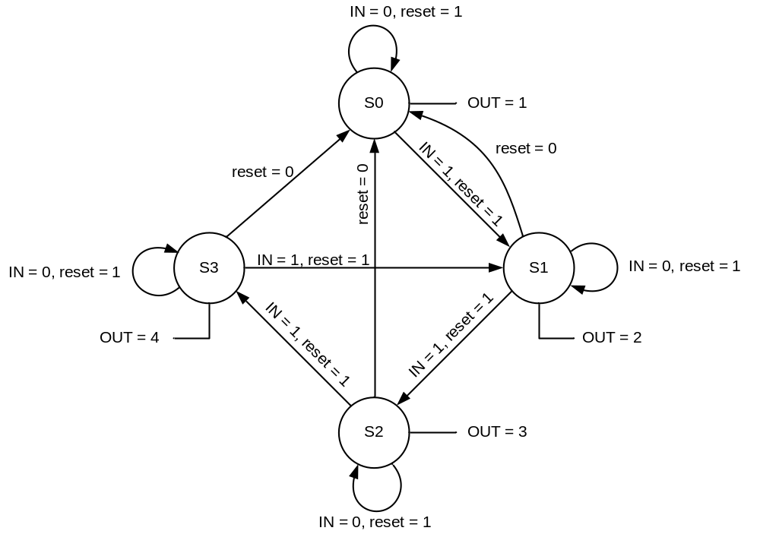
The state table becomes:

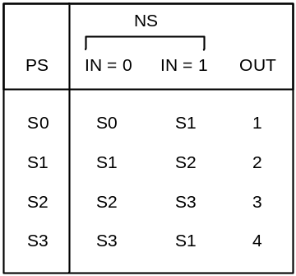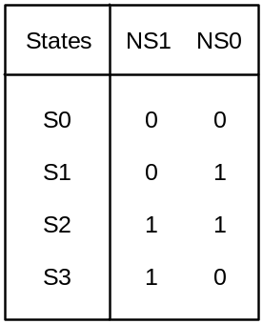

The transition table becomes:

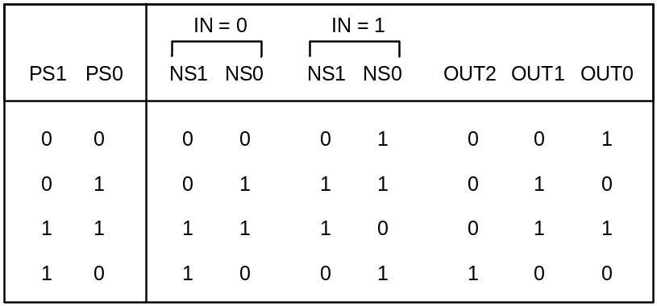

This yields the following Karnaugh maps and output functions:

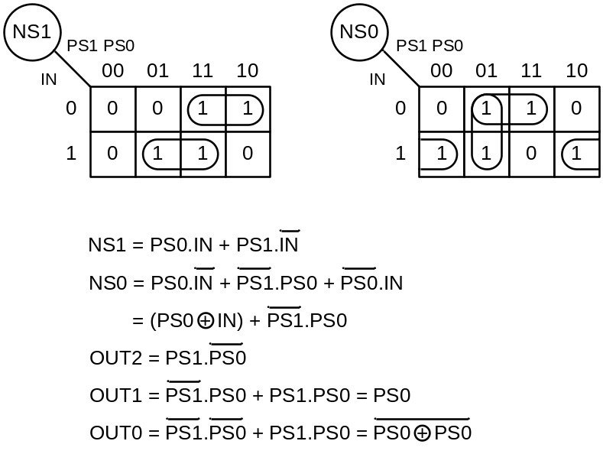

Finally, the resultant logic circuit of the Moore state machine becomes:

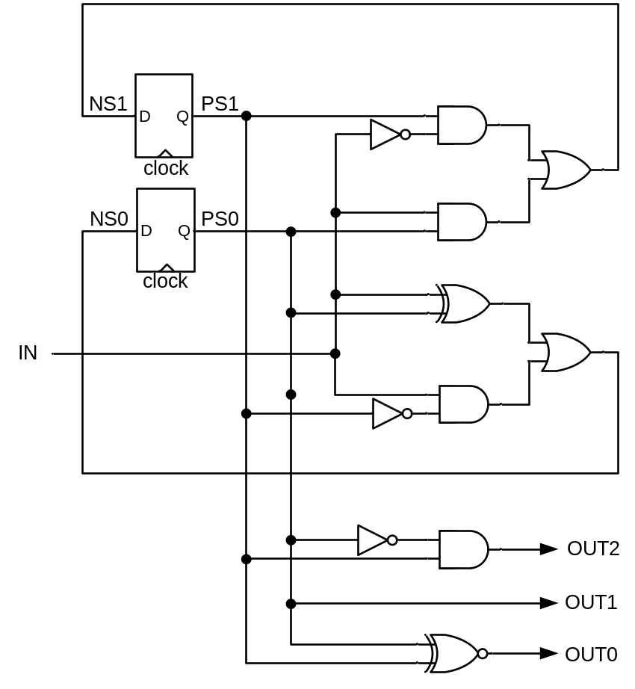

(B) Counter-Decoder Type Controllers

Implement the counter-decoder circuit below using RTL Verilog. In this circuit, apply logic 0/logic 1 to the Stop input to make transitions from one state to another.
Record the present state (CountOut) and the output (Out) of the state machine at each of the eight states below to verify the complete circuit functionality. Make sure to go to each state in sequence by applying the Stop input.

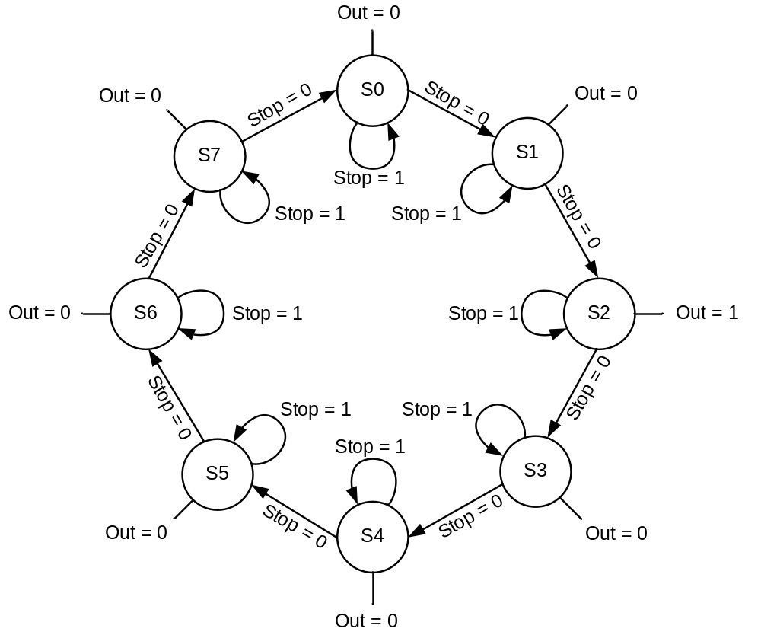

The timing diagram for the state machine becomes:

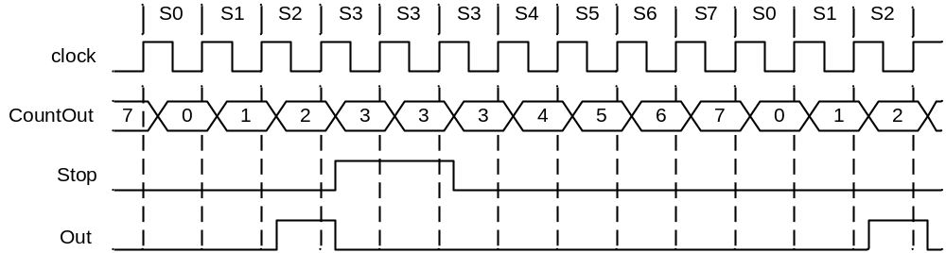

The resultant counter-decoder circuit becomes:

